ISAD 251 Application Design Document

Initial Storyboard (Customer section):

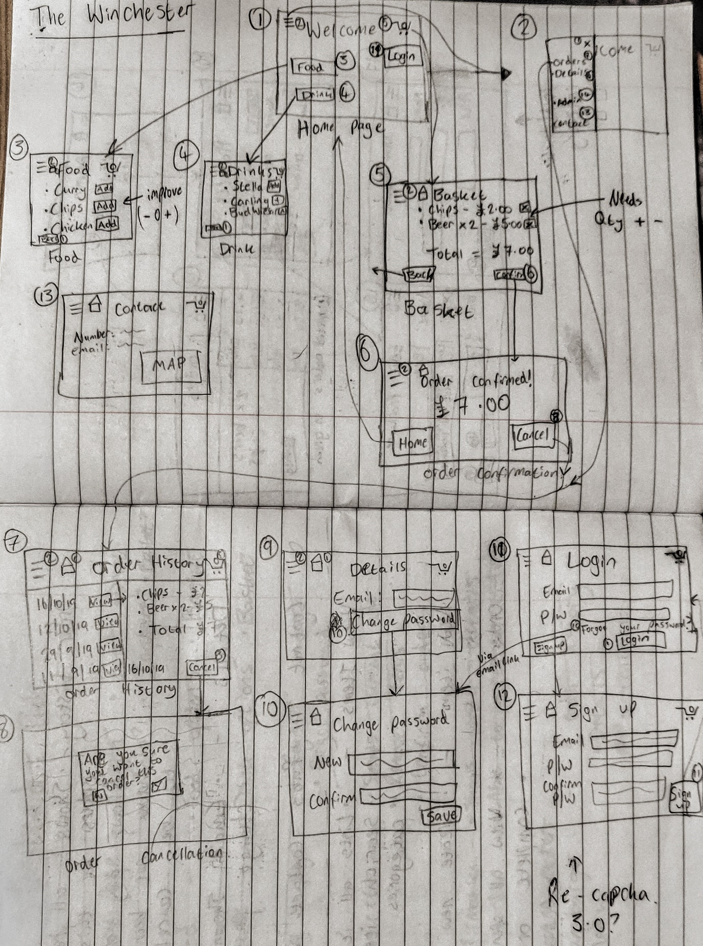

Initial Storyboard (Admin section):

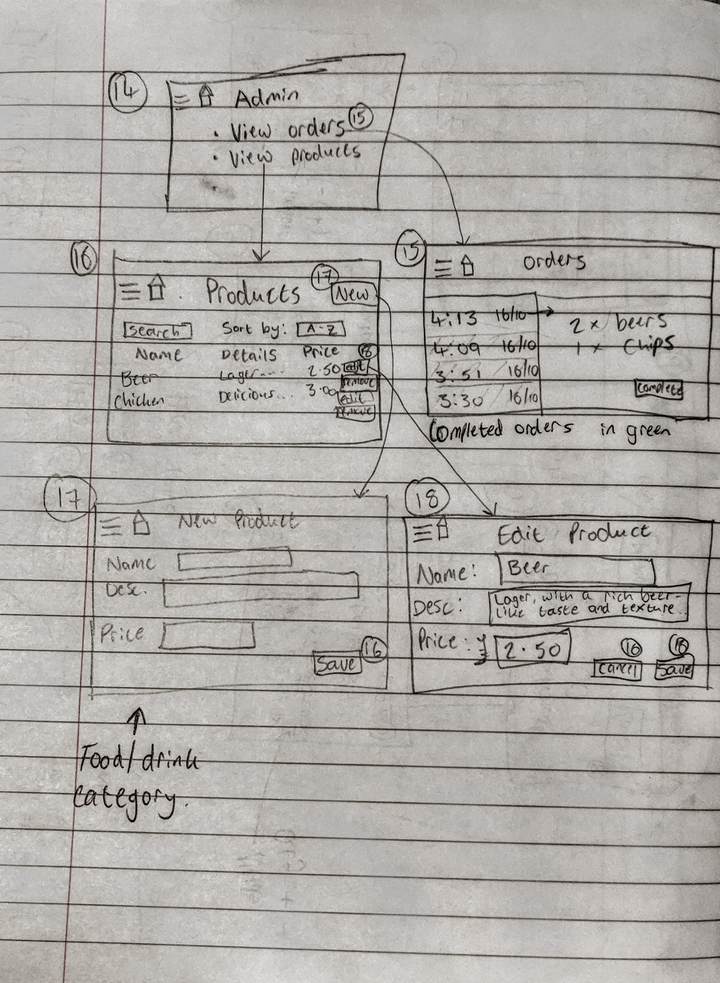

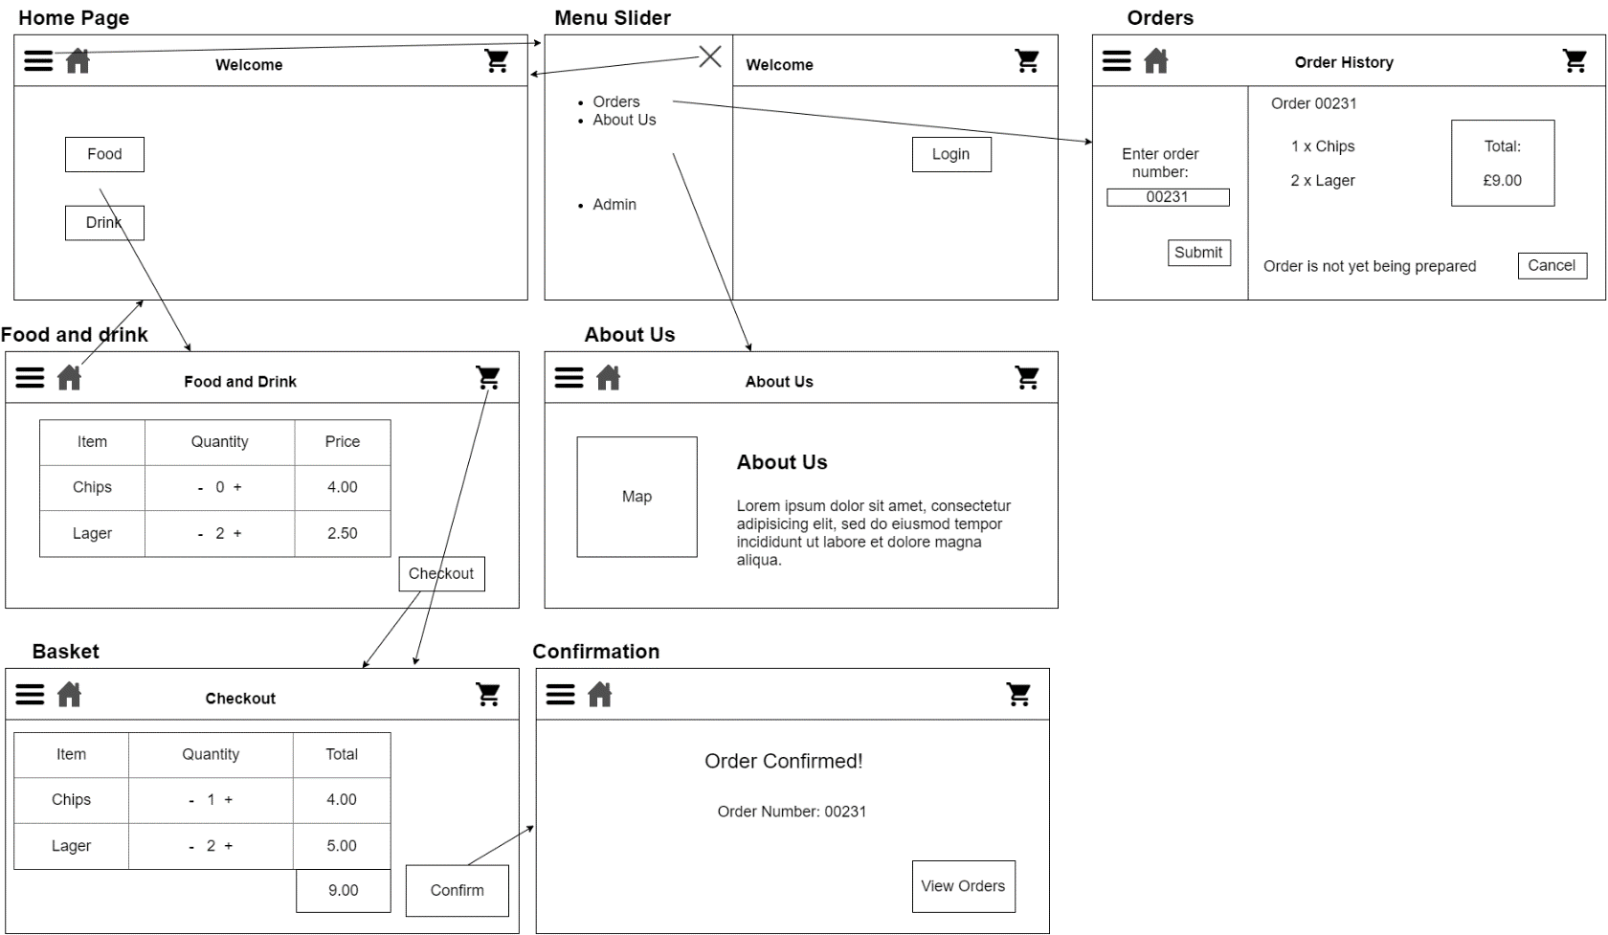Updated storyboard (Customer section):

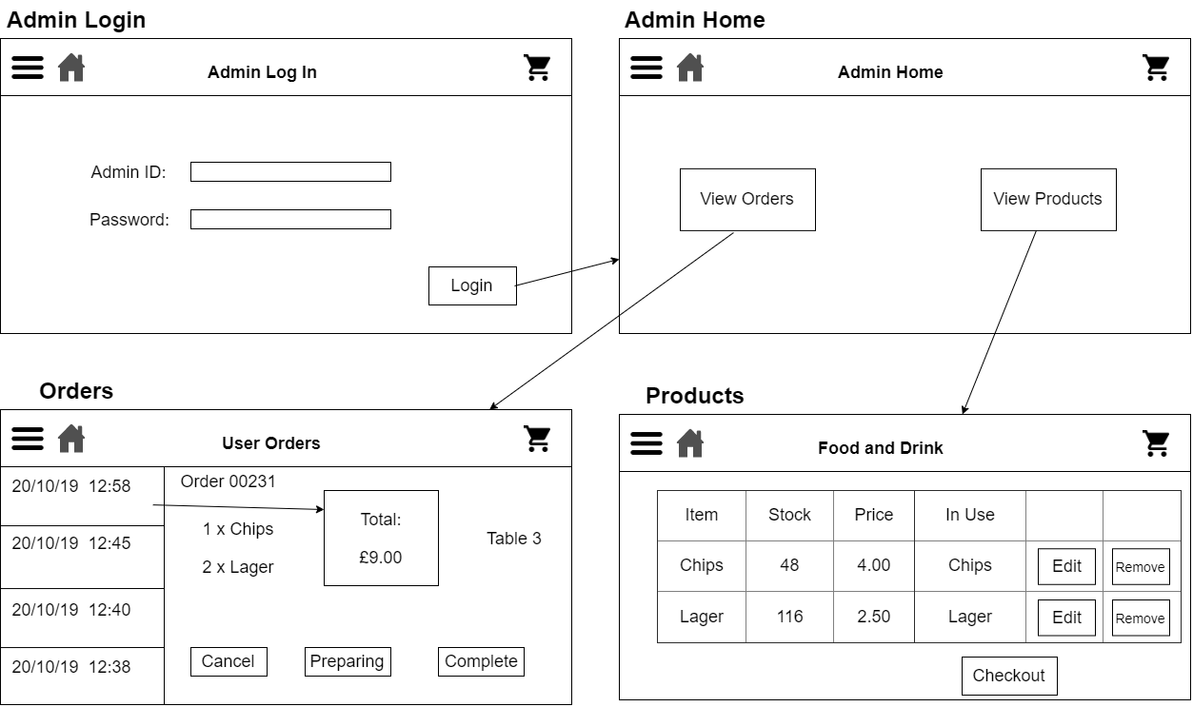Updated Storyboard (Admin section):

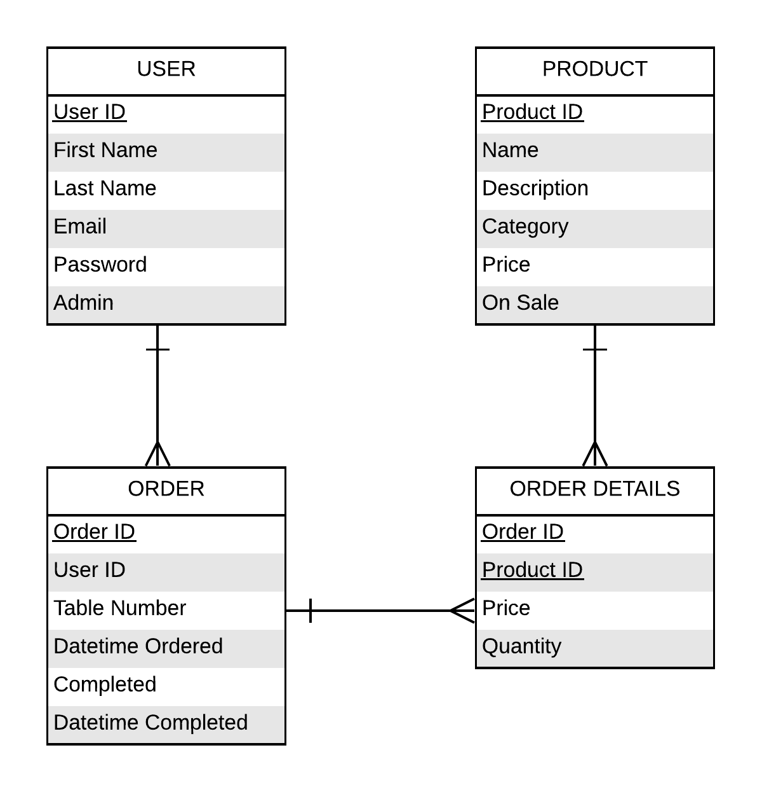Initial ERD:

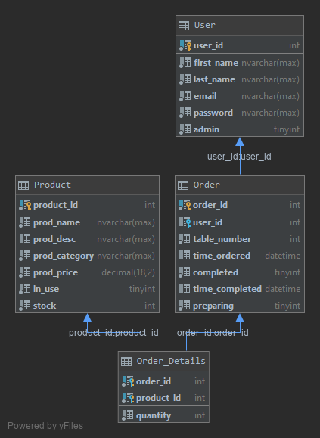IDE Generated ERD:

UML Diagrams:

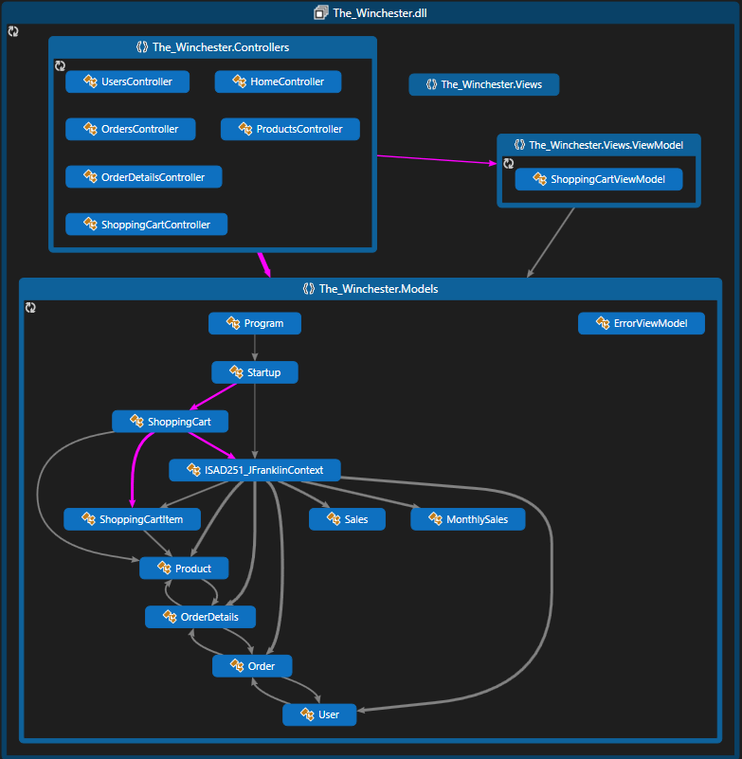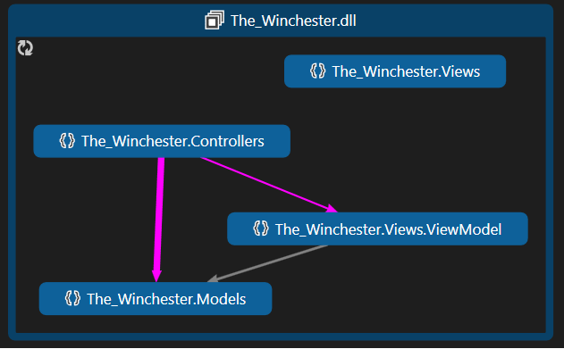

Web Accessibility Initiative (WAI)

According to the WAI website there are four Web Content Accessibility Guidelines (WCAG, ISO 40500, EN 301 549). Perceivable, operable, understandable and robust.

We’ll start with perceivable; this is about how easy it is to see the buttons, text, pictures, layout etc. I think the contrast in my navigation bar and footer help people to see what is the main focus of that page. I’ve made sure that all links, buttons and dropdowns are large and contrast the main page colour enough to make them obvious. There is also minimal typing, so something using a mouth-stylus, for example, would be able to order products quite easily, without the need for excessive typing. These things keeps the page operable, allowing people to see where they are navigating to with, what I hope is, ease.

I’ve kept the language simple, with little jargon, to conform with the understandable section. The fonts are quite large and in a style that is not hard to read. Most web browsers will have zoom and font options anyway to help people see text clearly (according to the User Agent Accessibility Guidelines - UAAG).

Robust is slightly harder to confirm, as someone using it would be using a text-to-speech generator, a high-level zoom, spoken commands etc. This would be something to test more if this project was taken from minimum viable product, to a full production project. If I’d had more time to work on it I would have liked to include a background colour change, high contrast modes, extra fonts specifically designed for people with dyslexia etc.

Peer Review Week 13 (Initial hand-drawn storyboard)

* Sophie Turner:
  + Said my basket needed a better way of altering the quantity, mentioned a plus and minus icon on either side would make it clearer for the user
* Dylan Beauchamp
  + Said the Admin section was quite good but pointed out that they would need a category section when creating products.
* Max Barker
  + Mentioned that my sign-up could use Google’s captcha 3.0 for the login, as setting up an email server was probably out of scope

Peer Review WC 06/01/2020 (Using website)

* Max Barker
  + Asked him to navigate through the site and then see what products were available.
  + “The site was user-friendly to navigate through; each link was easy to see and find. The Food and Drink page was missing some key features, the filter system wasn’t working and I couldn’t add anything to the basket. I enjoyed the clean look of the website and the scalability when making the window smaller would work well for mobile.”
* Dylan Beauchamp
  + Asked him to explore the Admin area of the website and add a new product
  + “The navigation was fine, the buttons for each section, large and obvious. The products and orders print straight out with no problems from the database. I was able to successfully add a product with ease. I would say that the login should really do something in the future.”

After my first round of feedback, there was a discussion of simplifying my project, so the captcha never made it into my project. The category creation made it into the final cut of the project of course, as did the feedback for the basket.

This brings us nicely onto things I would have liked to do if I had more time. I wanted to challenge myself with something new, but unfortunately underestimated how complicated ASP.Net core C# is. In hindsight, sticking to PHP may have allowed me to finish all the functionality for this product, but that’s a lesson learnt. First and foremost, finishing the functionality outlined in my plans. This includes the shopping cart, which I started working on but ultimately could not get working with the time left, which has a knock-on effect on the order history section, meaning no viewing or cancelling orders. The Admin section is mostly fine, I would have liked to be able to mark an order as being prepared and then complete and of course for the log-in to function as originally intended.

URLs

GitHub: <https://github.com/Frankles143/ISAD251CW>

Hosted Pages: <http://web.socem.plymouth.ac.uk/ISAD251/jsfranklin>

API: <http://web.socem.plymouth.ac.uk/ISAD251/jsfranklin/api> - This is actually not working as intended from the hosted URL, however if you open up “The_Winchester_API” and run the solution, the API does work.